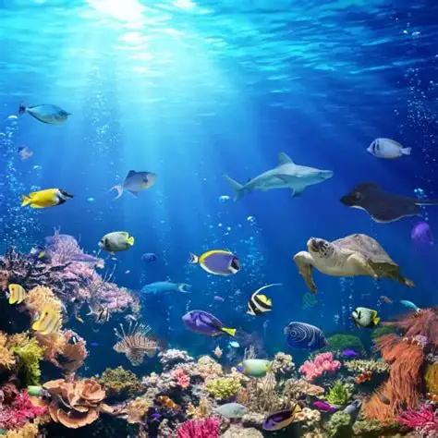 |     Reception Summer 2  Topic Overview – Under the sea  This term in Reception, we will continue to learn through carefully chosen key texts. We will learn through the stories, and continue to follow White Rose Maths. We will start to learn Phase 4 phonics and continue to practise our writing daily.
Super Start: On Monday 1st June Children can come to school dressed as a pirate, mermaid or a creature that lives under the sea. We will undertake many fun activities to launch our topic.
Epic End Parents and carers are invited in for an End of Year Family Fun Session. – this will be advertised on Dojo.
Please ensure that your child has their reading folder with their book inside every day. Please also support your child with their reading and writing daily as we start to transition them so they are ready for Year 1.
Trip to London Sea Life Centre – Ladybirds 30.6.26 Bumblebees 1.7.26
Our Learning Overview
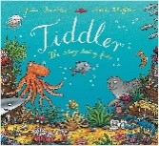
Key Texts



