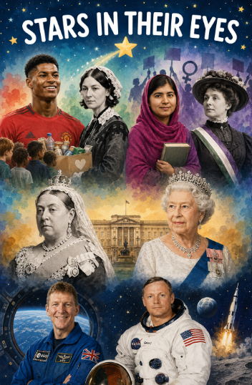 |  | Year 1 Summer 2 – Stars In Your Eyes  In our Stars in Their Eyes unit, children will learn about inspiring people who have changed the world. We will explore how figures such as Marcus Rashford and Florence Nightingale helped others through charity, and how Malala Yousafzai and Emmeline Pankhurst fought for equality. Children will also compare the reigns of Queen Victoria and Queen Elizabeth II, before discovering how astronauts Tim Peake and Neil Armstrong contributed to our understanding of space. Through this topic, children will develop their knowledge of significant individuals and the impact they have had on our lives today.
 |  | Super Start:  On Monday 1st June 2026, children are invited to come to school dressed as what they would like to be in the future! We will also be hosting a talent show, giving children the opportunity to showcase their special talents. Please ensure your child brings in any equipment or resources they may need for their performance. We look forward to seeing everyone’s creativity and talents! |  |  |  |  |  |  | Educational visit:  TBC
Our Learning Overview
Key Texts

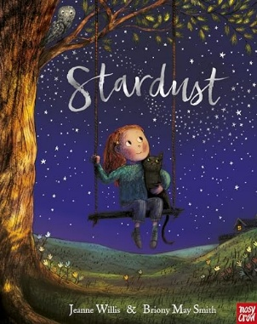
 |  |  |  | English |  | Children will explore recounts, instructions, discussions and narratives. They will develop their understanding of text features while building skills in grammar, vocabulary and sentence structure, including the use of suffixes, adjectives, time conjunctions and imperative verbs.
 |  |  |  | Maths |  | In Maths, children will continue to develop their understanding of place value within 100, as well as learning about money and time. They will practise recognising and counting coins, telling the time, and using numbers confidently in a range of practical activities.
 | Stars in your eyes |  |  | Science |  | We will explore plants and seasonal change. We will observe how flowers grow, identify a range of wild and garden plants and trees, and learn about the basic parts of flowering plants and trees. Children will also discover that fruit trees and vegetables are different varieties of plants.
 | Stars in your eyes |  |  | History |  | In History, we will learn about significant people who have changed the world. They will explore how figures such as Marcus Rashford, Florence Nightingale, Malala Yousafzai, Emmeline Pankhurst, Queen Victoria, Queen Elizabeth II, Tim Peake and Neil Armstrong.
 | Stars in your eyes |  |  | Art |  | In Art, we will explore the work of illustrator and watercolour artist Bryony May Smith. We will experiment with watercolour techniques, including colour mixing, blending lighter colours and painting in layers, to create watercolour artwork.
 |  |  |  | PHSE/RE |  | In PSHE, children will explore the theme of change and growing up. They will learn about life cycles, how people grow and change over time, and how to manage feelings linked to change. In RE, children will continue learning about Judaism and explore the celebration of Hanukkah, including why it is important and how it is celebrated by Jewish families.
 |  |  |  | Music |  | In Music, we will be continuing our lessons through listening, singing, and performing, while also developing our understanding of rhythm.

