 | 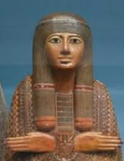 |  | Year 4 Summer 2  Topic Overview – All Wrapped Up!  This term, the children will be learning about ancient Egyptian life and culture, exploring topics such as pyramids, pharaohs, daily life, and traditions.
 |  |  | Super start: Children to come in dressed as an Egyptian Pharaoh.  Fab Finish: Learning showcase |  |  |  |  |  | Educational visit:  Art workshop at the National Gallery
 | Our Learning Overview
Key Texts

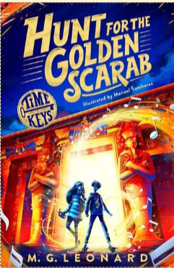

 |  |  |  |  |  | English |  | This term in English, the children will use Hunt for the Golden Scarab by M.G. Leonard to inspire their journalistic writing, narratives, and explanation texts, while developing their creativity, vocabulary, and confidence as writers.
 |  |  |  |  |  | Maths |  | As mathematicians, the children will be exploring shape and statistics, developing their understanding of properties of shapes, angles, graphs, charts, and data handling through a range of practical and problem-solving activities.
 |  | All Wrapped up! |  |  |  | Science |  | In Science this term, the children will be exploring living things and their habitats, learning how animals and plants adapt to their environments and investigating different life cycles and ecosystems through practical activities.
 |  |  |  |  |  | History |  | Throughout History this term, the children will be learning about the Ancient Egyptians, exploring their daily life, beliefs, achievements, and the importance of pharaohs, pyramids, and mummification
 |  |  |  |  |  | Art/DT |  | In Art this term, the children will be creating Egyptian-inspired sculptures and cartouches using collage and modelling techniques, while exploring the work of Howard Carter and developing skills such as pinching, rolling, coiling, and combining materials.
 |  |  |  |  |  | PSHE/RE |  | In PSHE we will look at how unique we are and the changes we experience around us.  In RE we’ll look at Christianity, focusing specifically on where, how and why Christians worship. In addition, we’ll look at baptism and key figures in Christianity
 |  |  |  |  |  | Music |  | In Music, we will be continuing our lessons through listening, singing, and performing, while also developing our understanding of rhythm.

