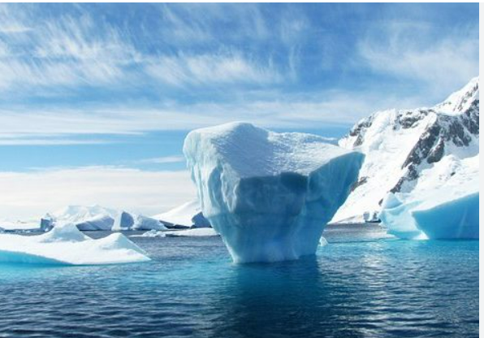 |  |   Year 3 Summer 2  Topic Overview – Frozen Kingdom  This term, we will be continuing our learning of the polar regions through a History topic called ‘Frozen Kingdom’. Through this topic we will be learning about famous explorers who ventured in the polar regions. We will learn about their exhibitions, focusing on how they were either successful or not.
 |  | Super Start: Children will create their own igloos out of cotton wool and marshmallows. |  |  |  |  |  | Educational Visits:  Maritime Museum for Polar Worlds workshop
Our Learning Overview
Key Texts

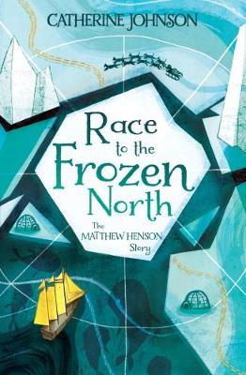

 |  |  |  |  | English |  | In English the children will be reading Race to the Frozen North written by Catherine Johnson. The children will be using their understanding to write an adventure story based in Antarctica. Furthermore, the children will write an expedition log for a key event from the text.
 |  |  |  |  | Maths |  | In Maths, we will be starting to look at time and will also explore shapes and recognising angles within a range of shapes. We will be able to identify a range of turns that a shape has performed. After shapes we will be looking at statistics and be learning about different charts and graphs that we can use to record data.
 | Frozen Kingdom |  |  |  | Science |  | In Science, we will be completing our Light topic. Children will explore how we see things, how light reflects from surfaces, how shadows are formed and change, and how to stay safe in sunlight through practical investigations.
 |  |  |  |  | History |  | In History, we will build on prior knowledge about Antarctica. The children will be learning about the expeditions of Roald Amundsen ad Robert Scott and the impact of their voyages.
 |  |  |  |  | Art |  | In Art, we will be exploring the work of land artists Andy Goldsworthy and Richard Shilling, looking at how natural materials can be used creatively. The children will experiment with clay and natural forms, designing their own clay imprints inspired by nature.
 |  |  |  |  | PSHE/RE |  | In PSHE, the children will be looking at ‘Changing Me’ including thinking about changes to their bodies as they grow, the change when there is a new baby and understanding different types of families. In RE, they will be answering the question ‘What is the best way for a Sikh to show commitment to God?’ They will learn all about the meaning of commitment and how to show devotion to a religion.
 |  |  |  |  | Music |  | In Music, we will be continuing our lessons through listening, singing, and performing, while also developing our understanding of rhythm.

