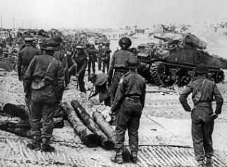 |  | ^{Year 5 Summer 2}  Topic Overview – “World War One”  Initially, children will be exposed to the “Why” behind World War One. Understanding what a war is, why it was important and why we still remember to this day. Once we have understood this, children look at what life was like in the trenches and gain some understanding of trench warfare. We dive deep into The Battle of the Somme - such an influential battle in WW1 where so many gave their lives to contribute towards the latter victory. Furthermore, children will be appreciating modern-day as they grow their understanding of what roles women and children had to play back in “Blighty” during the Great War.
 |  | Super Start: To prepare children for our WW1 topic, we will cover all the background knowledge needed before interacting with lesson content. We will be creating our own invisible message from a soldier to a fellow troop member and will create our own propaganda poster to convince civilians to join the war. |  |  |  |  |  |  |  | Educational visit: Imperial War Museum
^{Our Learning Overview}
^{Key Texts}
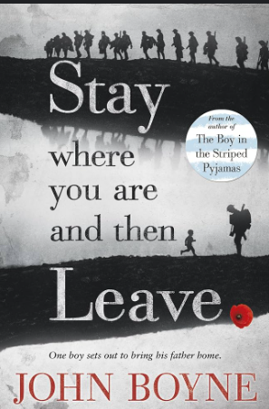

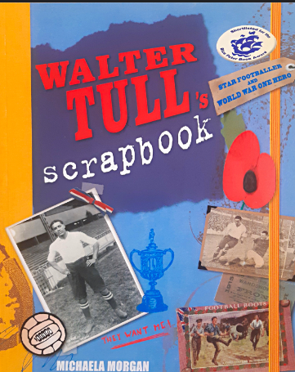
 |  |  |  |  | ^{English} |  | Children will be focusing on a range of genres in their writing, including an explanation text, journalistic report and a split-narrative. Each week children will learn a grammar focus which will be integrated into their writing.
 |  |  |  |  | ^{Maths} |  | Children will be getting stuck into negative numbers this half-term. We will count through zero, order and compare as well as solving problems. On top of this, we will explore how negative numbers relate to real life, such as thermometers, buying items and supporting the understanding of common interactions, including levels within buildings.
 | ^{ALL} |  |  |  | ^{Science} |  | In Science, we will be looking at changes of materials, focusing on exploring irreversible and reversible changes, chemical reactions and taking part in a range of experiments.
 |  |  |  |  | ^{History} |  | Year 5 will explore World War I this term, understanding life for the troops in the trenches and those on the home front. They will further explore the causes and consequences of the Great War, contributions of those who remained behind and will understand how soldiers are remembered in our modern society.
 |  |  |  |  | ^{DT} |  | In DT this term, we will be studying textiles, working towards making a WWI smoke hood bag. We will formulate a brief, ensuring we are designing for the use of soldiers, research appropriate materials, learn and practise different stitches and finally make and evaluate our designs.
 |  |  |  |  | ^{PSHE/RE} |  | In PSHE this term, the children in Year 5 will be learning about ‘Changing me’. This topic will be covering how we change as we are growing. In RE, We will be exploring how Christians best show commitment to god through their actions and beliefs, and how it is similar and different to the religions we have studied so far.
 |  |  |  |  | ^{Music} |  | Children will be continuing to learn and play the violin in music.

