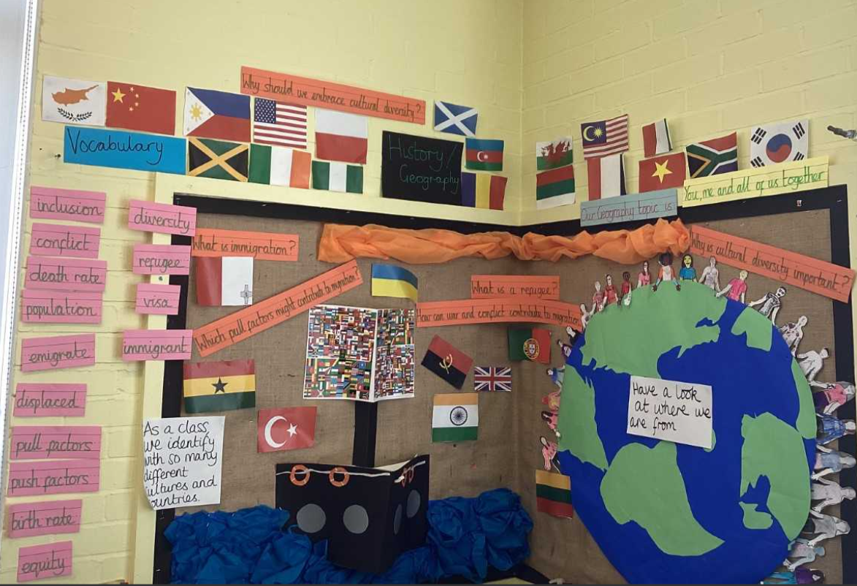 |  |  | 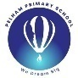  Year 6, Summer 2- You, Me and All of Us Together.  Topic Overview - During this half –term, the children will learn about the impact of Windrush and how it continues to affect many people today. The children’s core text is called Windrush Child, by Benjamin Zephaniah. As a year group, the children will be reflecting on their time in primary school and celebrate all their achievements! They will deliver a Year 6 production and leavers’ assembly to showcase their successes and talent. Additionally, some children will be going on the residential and the others will be engaging in various activities too!
Our Learning Overview
Key Text

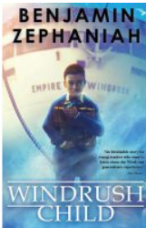
 |  |  |  |  | English |  | We will be learning how to use the story Windrush Child by Benjamin Zephaniah to inspire our writing. We will explore the thoughts and feelings of the main character and write in different styles such as diary entries, letters, and poems. We will learn how to show emotion through our writing, use powerful vocabulary, and develop our own voice as authors.
 |  |  |  |  | Maths |  | As Mathematicians, the children will be using their arithmetic, reasoning and problem-solving skills to engage in various maths-related projects.
 | You, Me and All Of Us Together |  |  |  | Science |  | In Science, we will be consolidating our learning on classification and engage in a variety of science projects, centred around the Crest Awards!
 | You, Me and All Of Us Together |  |  |  | History |  | In History, we will explore how the Windrush Movement shaped modern Britain. We will find out why people from the Caribbean were invited to move to the UK after World War II, and what life was like for them when they arrived. We will explore the challenges they faced, including racism and unfair treatment, as well as the important contributions they made to British society. This will help us understand more about migration, identity, and the value of diversity in our history.
 | You, Me and All Of Us Together |  |  |  | Art |  | In Art, we will plan and create a piece of artwork about ourselves. This piece will be produced to show others who we are and who we want to be.
 |  |  |  |  | PHSE/RE |  | In PSHE, students will continue to learn about the importance of healthy relationships within families, friends and the community as well as exploring the changes when growing up. In RE, the children will continue to learn about Christianity, with a key focus on: Is Christianity still a strong religion 2000 years after Jesus was on Earth?
 |  |  |  |  | Music |  | In Music, we will be continuing our lessons through listening, singing, and performing, while also developing our understanding of rhythm.

