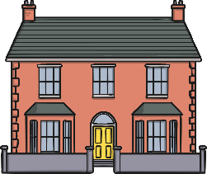 | YEAR 1 • AUTUMN 2 There’s no place like home.  The children will be exploring key human features, e.g. cities, towns and shops. They will be learning to identify the countries that make up the United Kingdom and use simple compass directions. (North, South, East and West). We will be exploring the local environment and our surroundings.
SUPER START  We will be looking at different types of homes. We will design a room and use cardboard boxes and recycled materials to bring it to life! We will be going on a scavenger hunt to find key features of the United Kingdom. We will be dressing up as our dream jobs. | Epic End:  Learning Showcase | EDUCATIONAL VISIT  Dates to be confirmed  Map reading and orienteering  Visit to the church | UNICEF  Life on Land  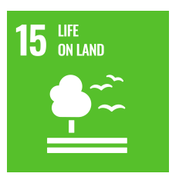
OUR LEARNING THIS HALF TERM
ENGLISH  Our focus in English will be on narratives and using past and present tense. We will continue to focus on using capital letters correctly as well as the conjunction ‘and’. We will also be introducing suffixes to the children focusing on -ing, -ed, -er. | MATHS  In Maths, we be continuing to develop our knowledge of place value with numbers to 10. We will be learning to add numbers to 10 and subtract within 10. We will be learning to use the part-whole model to partition numbers. We will be learning about fact families and number bonds within 10.
SCIENCE  For our Science learning, we will be learning about seasonal changes in Autumn and Winter. We will be observing and describing the different weather associated with the seasons and observing what happens to the plants, trees and wild life. We will also be continuing our learning on Materials from this half term and learning new vocabulary to extend our knowledge. | Geography  In geography, we are learning about our local area. We will identify local landmarks and talk about why they are important. We will use Google Maps to navigate the local area. We will learn to name the countries in the UK and talk about different homes. We will talk about the different jobs in the community
ART / DT  In Art, we will be learning about printing techniques. We will explore shapes and patterns and have a go at mixing colours. We will use natural materials to make our own prints. | PSHE / RE  Our PSHE topic will be Celebrating Differences. We will look at similarities and differences between us and our friends and talk about what to do if we feel unhappy or feel like we are being bullied. We will discuss how to be a good friend and talk about what makes us special. In RE we will be learning about Christianity, focusing on the Christmas story and how it feels to receive a special gift.
MUSIC  In Music we will taking part in a weekly music session with a specialist teacher. We will be learning how to use our voices focusing on pitch. | KEY TEXTS  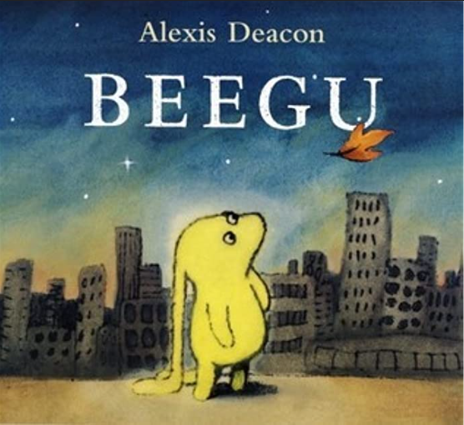  Beegu | PE  In PE, we will be developing our gymnastic skills. Where we will work on flexibility and balance.

