 | 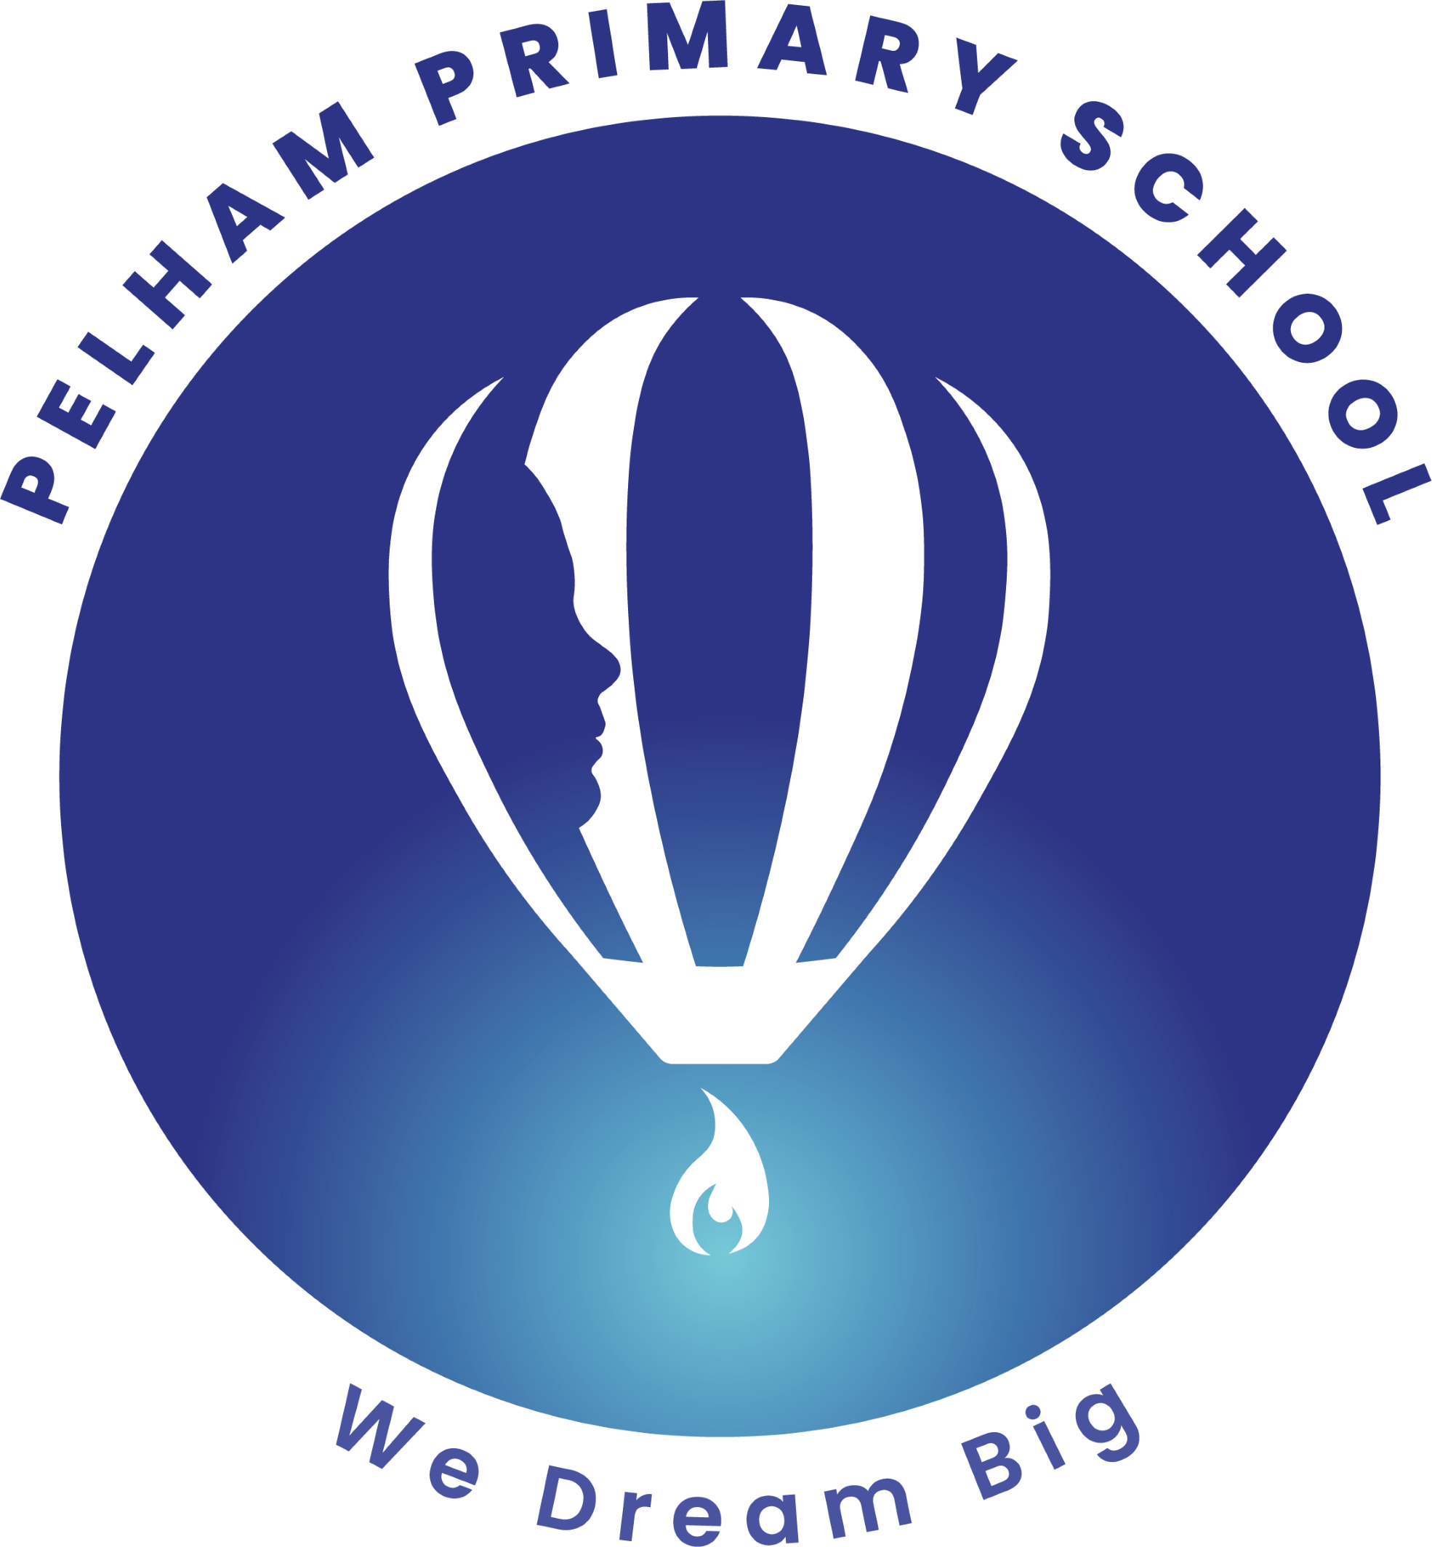  YEAR 2 • AUTUMN 2 JURASSIC WORLD  This term, we will be stepping back in time to explore the fascinating world of dinosaurs! Through our learning, children will discover how living things have changed over time and explore habitats around the world. We will develop our geographical knowledge by locating continents, oceans and different habitats, while learning how animals and plants are suited to the environments in which they live.  We will also explore food and nutrition, celebrate what makes each of us unique, develop our understanding of rhythm and musical performance, and use computing to become route explorers. Across the term, children will be encouraged to work collaboratively, solve problems and share their ideas creatively.
Super start  We will kick-start our Jurassic World topic by becoming palaeontologists! Children will explore dinosaur fossils, investigate clues from the past and learn how fossils can help us understand what life was like millions of years ago.  We will also create our own dinosaur investigations, using maps, observations and teamwork to discover where different dinosaurs may have lived. | Epic End:  Our learning will culminate in a Jurassic World celebration, where children will showcase their learning through creative work, writing, science investigations and dinosaur-inspired activities. | Educational visit  Natural History Museum Workshop  Children will have the opportunity to develop their learning about animals, habitats and the natural world through a workshop at the Natural History Museum. | UNICEF  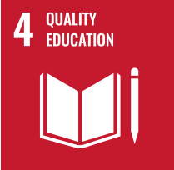  Zero Hunger/Quality of education  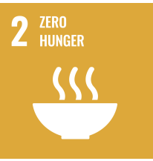
Our learning this half term
English: Tyrannosaurus Drip by Julia Donaldson and David Roberts and Fossil Girl  This half term, we will be using Tyrannosaurus Drip to inspire our English, science and creative learning. Children will explore the story of a small dinosaur who feels different from those around him and discover themes of belonging, friendship, identity and celebrating differences. They will develop their narrative writing by using:  Expanded noun phrases to describe dinosaurs and settings,  past tense verbs to recount events, conjunctions such as and, but, because, when accurate punctuation, interesting vocabulary and descriptive language, story maps to plan the beginning, middle and end  character descriptions and diary/recount writing. Children will also develop their retrieval, inference and prediction skills through questions about the text. Through the text, children will develop their vocabulary, comprehension and writing skills while learning about dinosaurs and the environments in which they lived. | Maths: ADDITION & SUBTRACTION  In Maths, we will follow White Rose Maths to develop our understanding of addition and subtraction. Children will use practical resources, drawings and written methods to add and subtract numbers, solve one- and two-step problems, and explain their mathematical thinking.
Science  The dinosaurs in our story will provide an exciting introduction to learning about living things and their habitats around the world.  Children will explore:  Different habitats  How animals are suited to their environments  What animals need to survive  Food chains  Herbivores, carnivores and omnivores  Producers and consumers  How habitats can change | Geography  In Geography, we will explore different habitats around the world. Children will locate and identify continents and oceans and investigate where different animals and plants live. We will compare different environments and explore how climate, location and physical features affect the animals and plants that can survive there...  Computing:  In Computing, we will become Route Explorers!  Children will learn how to create and follow algorithms and routes, giving clear instructions to reach a destination. They will develop their understanding of direction, sequencing, commands and debugging as they solve different route-based challenges.
ART / DT  DT – FOOD AND NUTRITION  In DT, children will learn about healthy eating and nutrition. They will explore different food groups, learn about the importance of a balanced diet, and develop practical skills such as preparing, chopping and mixing ingredients safely. Children will design, make and evaluate a simple healthy food product. | PSHE / RE  Tyrannosaurus Drip provides opportunities to discuss how it feels to be different from others. Children will explore the importance of being kind, accepting differences and making everyone feel that they belong.  We will discuss: “It is okay to be different. “Children will learn to recognise and celebrate the qualities that make themselves and others unique.  RE: The good news Jesus brings  In RE, children will explore the good news Christians believe Jesus brings, including messages of peace, forgiveness, love, hope and kindness. They will explore stories and teachings of Jesus and discuss how Christians may put these values into practice in their everyday lives.
MUSIC  In Music, we will explore rhythmic patterns and performance technique.  Children will develop their ability to keep a steady beat, recognise and perform rhythmic patterns and work together as an ensemble. They will have opportunities to use their voices and instruments to create and perform rhythmic pieces. | 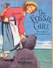  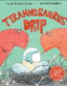  Key texts  Jurassic World / dinosaur-themed texts.  Tyrannosaurus Drip by Julia Donaldson and David Roberts  Fossil Girl by Catherine Brighton | PE – target games  In PE, children will develop their throwing, aiming and accuracy skills through a range of target games. They will learn to follow rules, work as part of a team and improve their coordination, control and sportsmanship.

