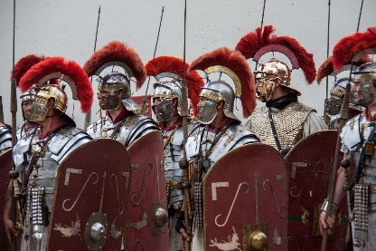 |   YEAR 3 • AUTUMN 2 WHAT DID THE ROMANS DO FOR US?  The children will use their understanding to place Roman invasions accurately on a map and a timeline. The children will explore the significance of the Roman Army and learn about important Roman Battles. They will also develop an understanding of what Romans did to support Britain.

SUPER START  Animal mosaics  Roman shields | SHOWCASE  Present our learning this term collectively | EDUCATIONAL VISIT  MathsWorld - London | UNICEF articles – linked through core text or other curriculum areas.  Right to access information (Article 17)  Right to relax and play (Article 31)
OUR LEARNING THIS HALF TERM
ENGLISH  This half term, Year 3 children will develop their writing through stories, information texts and news reports. They will write engaging stories, creating characters, plots and settings, while using apostrophes for possession and adverbs to add detail. They will write information texts using conjunctions, adverbs and prepositions, organising ideas into paragraphs and using headings and subheadings. They will also explore journalistic writing, learning to use past and present tense, inverted commas for speech and conjunctions to link ideas. Children will create eye-catching headlines and continue to develop their spelling, punctuation, grammar, vocabulary and confidence as writers. | MATHS  As mathematicians, the children will complete their learning on addition and subtraction before moving on to multiplication and division. They will develop their understanding of different mathematical methods and learn how to apply these skills to a range of calculations and problems. Throughout these topics, children will be encouraged to explain their thinking and use their reasoning skills to find solutions. They will also tackle a variety of problem-solving activities, helping them to become more confident and independent mathematicians. Our focus will be on developing accuracy, understanding and mathematical fluency, while encouraging children to make connections between different areas of their learning.
SCIENCE  In Science, the children will be learning about forces and magnets. They will investigate how magnets work and explore the strength of different magnets. Children will also investigate how objects move across different surfaces and consider how the surface can affect movement. They will explore a range of materials and conduct experiments to identify which materials are magnetic and which are non-magnetic. Through practical investigations, children will develop their scientific enquiry, observation, prediction and reasoning skills. | HISTORY  In History, the children will explore the Roman invasion and settlement of Britain, learning why the Romans came and how they built their vast empire. They will investigate the life of a Roman soldier and discover what everyday life was like for people living in Roman Britain. The children will also learn about Pompeii and its importance within the Roman Empire. Finally, they will explore how Roman Britain changed over time and consider the lasting impact and legacy the Romans left behind.
ART  This term, the children will be creating their own Roman mosaic. They will be looking at the importance of mosaics, learning about repeating patterns and designing and making their own mosaic. These will then be showcased to parents at the end of the term. | PSHE / RE  In PSHE this term, we are going to be looking at celebrating differences between people. In RE, we are going to be looking at this question “What is the Trinity and why is it important for Christians”
MUSIC  This term, Year 3 will continue developing their musical skills through Stretto Music. They will explore playing, composing, performing and improvising, building confidence, creativity and musical understanding through a range of engaging activities and practical experiences. | 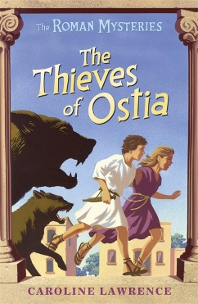  KEY TEXTS | PE  This term, Year 3 children will be developing their dance skills through an exciting Roman-themed unit. They will explore movement, rhythm, balance, coordination and different levels, while learning how to create and perform sequences. Children will work individually, in pairs and groups to develop their own Roman-inspired dances, using actions and movements to represent Roman soldiers, battles, celebrations and daily life. They will also build confidence and teamwork skills.

