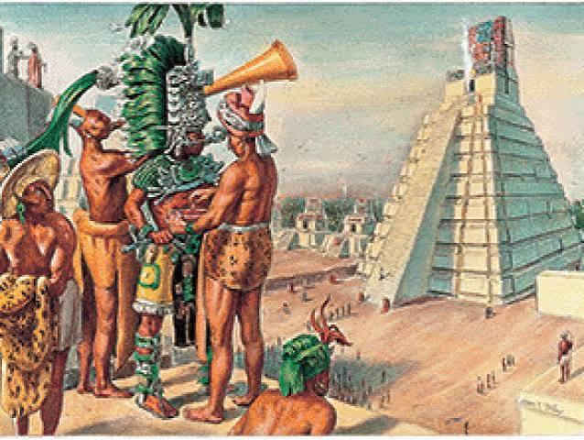 |   YEAR 4 • AUTUMN 2 ¡HOLA!  In history, Year 4 will be learning about the Maya civilisation and discovering what life was like for the Maya people. Children will explore where and when the Maya lived and investigate their cities, homes, religion, beliefs and everyday lives. They will learn about the Maya’s impressive achievements, including their writing, calendars, number system, architecture and farming methods. Children will use a range of historical sources to ask questions, make comparisons and develop their understanding of how the Maya civilisation has influenced the world today.

SUPER START  Junk modelling to create our own Maya temples. | SHOWCASE  Presenting our learning on the Mayans. | EDUCATIONAL VISIT  Making pizza workshop and exploring the origins of food – date TBC | UNICEF articles – linked through core text or other curriculum areas.  Best interests of the child (Article 3)  Right to health, water, food and safe environment (Article 24)
OUR LEARNING THIS HALF TERM
ENGLISH  This term, Year 4 will be building their SPAG (Spelling, Punctuation and Grammar) skills through a range of exciting writing opportunities, including narrative, persuasive and recount writing. They will learn how to use fronted adverbials to add detail and variety to their sentences, as well as using apostrophes accurately for contractions and possession. Children will apply these skills in their own writing, developing greater accuracy, confidence and creativity as they write for different purposes and audiences. |  | MATHS  In maths, we will continue to develop their understanding of addition and subtraction, using efficient written and mental methods to solve increasingly complex problems. Children will explore measurement and area, including calculating and using appropriate units of measurement. They will also be building fluency with multiplication facts and applying these skills to solve calculations and problems. Children will be encouraged to explain their reasoning, choose appropriate methods and apply their mathematical skills to a range of practical and problem-solving situations.
SCIENCE  In science, Year 4 will be learning about sound and how it is produced. Children will explore how sounds are made when objects vibrate and investigate how vibrations travel through different materials to reach our ears. They will explore how the volume and pitch of sounds can be changed and carry out practical investigations using a range of instruments and everyday objects. Children will develop their scientific enquiry skills by making predictions, carrying out fair tests, recording observations and using their findings to explain how sound works. |  | DT  In DT, Year 4 will be learning about food and nutrition. Children will explore the importance of a healthy and balanced diet and learn about the different food groups and nutrients our bodies need. Children will design, make and evaluate their own pizzas, considering taste, appearance, texture and nutritional value while developing their understanding of food hygiene and kitchen safety.
RE  In RE, Year 4 will be learning about Pentecost and its importance to Christians. Children will explore the events of Pentecost and learn about the coming of the Holy Spirit to Jesus’ disciples after his ascension. They will consider how this experience gave the disciples courage and confidence to share the Christian message with others. Children will explore why Pentecost is an important event in the Christian Church and consider how Christians today understand and celebrate the presence of the Holy Spirit. |  | PSHE  In PSHE (Jigsaw), Year 4 will focus on the theme Celebrating Difference and developing their understanding of how people can be different while still sharing many similarities. Children will consider how appearances can influence the way people are judged and explore the different influences that can shape our thoughts and opinions. They will learn about bullying, how it can affect others and ways to respond appropriately. Children will develop their problem-solving skills and explore what makes each person special and unique. They will finish by celebrating differences in the way people look and recognising the importance of respect, acceptance and kindness towards others.
MUSIC  We will continue to enjoy our weekly music lessons with the specialist music teacher. More information will be shared via Dojo. | KEY TEXTS  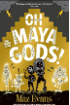 |  | PE  This term, Year 4 will be learning about dance. Children will developing their ability to create and perform sequences using different shapes, levels, directions and rhythms. They will work individually, in pairs and in groups to develop and link movements together, focusing on timing, coordination and expression. Children will also learn to perform confidently and evaluate their own and others’ performances.

