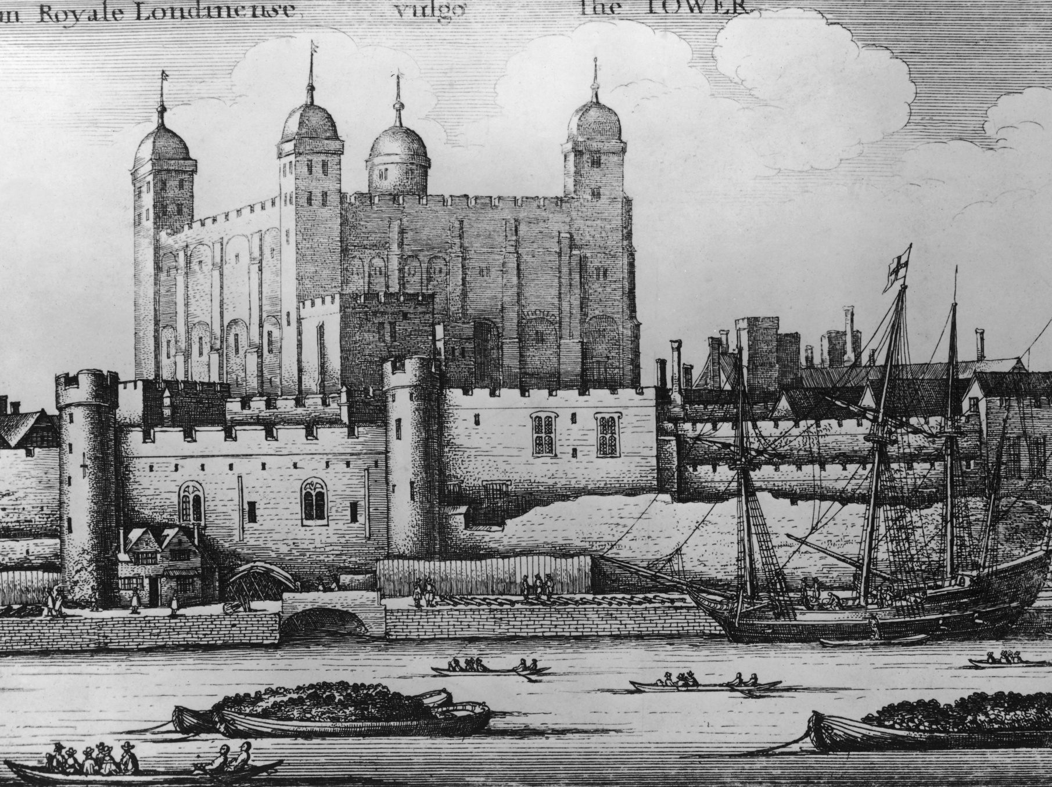 | 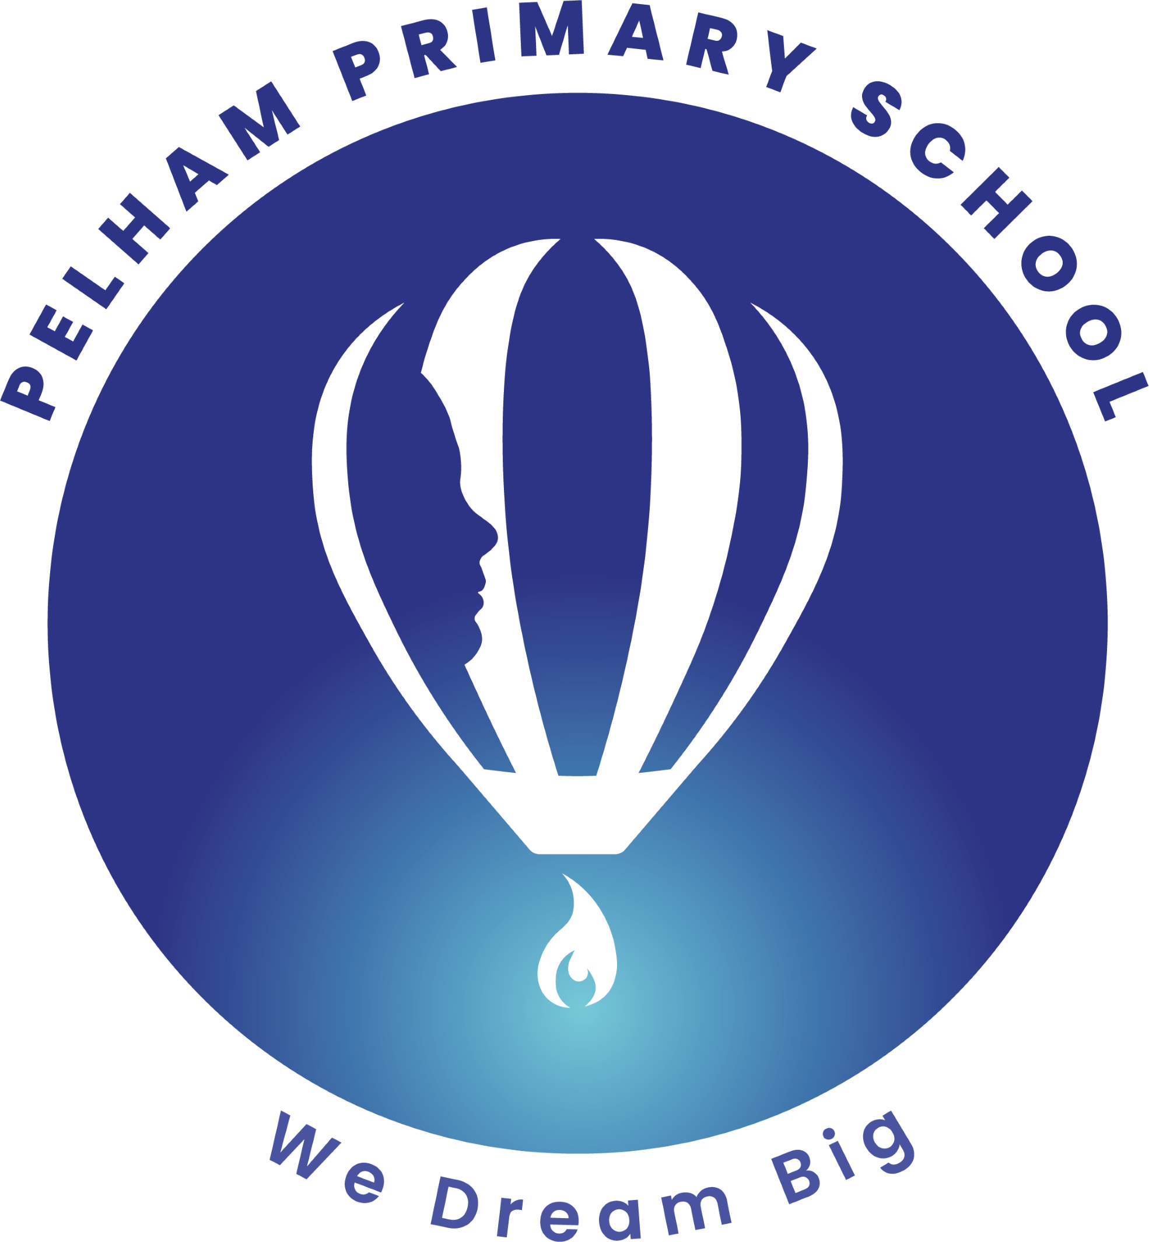  YEAR 6 • AUTUMN 2 DOES THE CRIME FIT THE TIME?  This half term, Year 6 will explore how geography can influence crime, punishment and safety. Children will investigate how the River Thames influenced the location of the Tower of London and how the growth of Victorian London affected crime. They will explore the routes used to transport convicts from the UK to Australia and consider how natural features such as rivers, islands and terrain can act as barriers. Children will also design a safer town, thinking about how the layout of a community can help reduce crime and support rehabilitation.

SUPER START  Year 6 will investigate a mysterious crime scene, examining clues such as footprints, fingerprints, torn notes and witness statements to solve the mystery. Working in teams as detectives, children will analyse the evidence, identify possible suspects and explain their conclusions. They will then explore how crime and punishment have changed throughout history, comparing punishments from different periods and considering how ideas about justice have developed over time. | EPIC END  Learning Showcase – Children will have the opportunity to share and celebrate their learning from this half term. | EDUCATIONAL VISIT  Workshop |   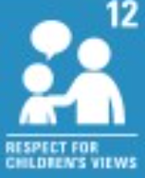  UNICEF articles – linked through core text or other curriculum areas.
OUR LEARNING THIS HALF TERM
ENGLISH  In English, Year 6 will explore a range of writing genres, including narrative, information texts and journalism. Children will develop their writing skills by using dialogue to develop characters and move the action forward, as well as creating settings and atmosphere. They will also use punctuation such as commas, colons, dashes and brackets, and learn how to organise information clearly. Through journalistic writing, pupils will explore formal and informal language, direct and reported speech, and different organisational devices to communicate effectively for a range of purposes and audiences. | MATHS  In Maths, Year 6 will follow the White Rose Maths curriculum, focusing on fractions and measurement. Children will learn to compare, order and simplify fractions, as well as add, subtract, multiply and divide fractions. They will also develop their understanding of measurement by converting between units of length, mass, capacity and time. Children will use these skills to solve problems, explain their thinking and apply their knowledge to real-life situations.
SCIENCE  In Science, Year 6 will explore Light and how we see the world around us. Children will learn that light travels in straight lines and that we see objects when light travels from a light source to our eyes, either directly or by reflecting off an object. They will investigate how light creates shadows and use their understanding of light to explain why shadows have the same shape as the objects that make them. | GEOGRAPHY  In Geography, Year 6 will explore how physical and human geography can influence crime, settlements and safety. Children will investigate how the River Thames influenced the location of the Tower of London and use maps to explore how the growth of Victorian London affected crime. They will trace the routes used to transport convicts from the UK to Australia and explore how natural features such as islands, currents and terrain can act as barriers. Children will also design an urban plan that helps to reduce crime and create safer communities.
ART / DT  In Design and Technology, Year 6 will build on their understanding of pulleys, gears and mechanical systems. Children will develop their skills in constructing circuits and using construction kits. They will design, make and evaluate their own detective gadget, inspired by their Crime and Punishment topic. Children will use their creativity and problem-solving skills to create a functional product for a specific purpose and audience. | PSHE / RE  In RE, Year 6 will explore why Christians believe Jesus was the Messiah. Children will learn about Christian beliefs about Jesus and how these beliefs influence the way Christians live and treat others.  In PSHE, Year 6 will focus on Celebrating Differences. Children will learn about accepting and respecting others, understanding differences and showing empathy. They will explore bullying, discrimination and inclusion, and learn how to treat others with kindness and respect.
MUSIC  In Music, Year 6 will focus on developing their skills on the violin. Children will learn to play simple melodies, develop their understanding of rhythm and pitch, and improve their technique through regular practice. They will also have opportunities to perform and play together, building their confidence and enjoyment of music. | KEY TEXTS  Holes | PE - In PE, Year 6 will focus on gymnastics, developing their jumping, landing and movement skills. Children will use apparatus safely, create different shapes and movements, and work together to perform sequences. They will also develop perseverance, teamwork and confidence.

